Capstone Report:
Economic Analysis of Development Around the Phoenix Light Rail

Chris Coker
Mesa Community Collage
CIS 480
Dr. Kazuaki Kashihara
9/18/2025
Capstone Report:
Economic Analysis of Development Around the Phoenix Light Rail
Introduction and Rationale
This capstone project presents an economic analysis of transit-oriented development in Phoenix, Arizona, focusing on the impact of proximity to light rail stations on residential neighborhoods and commercial business activity over a period (2008-2023). Phoenix offers an ideal case study given its rapid metropolitan growth, recent light rail implementation, and well-documented development patterns.
My interest in this topic stems from previous research on light rail for a class project on Arizona geography, which raised complex questions about the economic and social consequences that extend beyond that project. This project enables engagement with the data analytics lifecycle, encompassing collection, preparation, analysis, regression modeling, and visualization, to address critical urban development questions.
The research addresses a vital urban policy debate. As U.S. cities invest billions in transit infrastructure, understanding actual economic impacts becomes essential for informed decision-making (Credit, 2018). These findings could guide policymakers in optimizing transit investment and implementation strategies.

Research Objective and Questions
The primary objective is to quantify and analyze the causal economic effects of light rail transit development on residential housing markets and commercial business activity in Phoenix, Arizona, using statistical and machine learning methodologies to inform urban policy decisions.
This research addresses two interconnected questions:
- Causal Impact Analysis: Does proximity to light rail stations causally increase housing values and business establishment density, creating measurable economic development clusters around transit nodes?
- Sectoral Business Response: Which business types (retail, services, restaurants, professional services) show the strongest positive response to improved transit access, and how does this development vary by existing neighborhood socioeconomic characteristics?

Literature Review
Summaries
The Social Justice Impact of Transit-Oriented Development, Seunghoon Kim
This study by Seunghoon Kim examines the impact of light-rail transit-oriented development (LRTOD) in Phoenix, Arizona, on household discretionary income (DI), which is the amount of money remaining after housing and transportation expenses are covered. The goal is to determine if transit-oriented development (TOD) makes living more affordable or adds to inequality.
Kim analyzed data from the Location Affordability Index (LAI) for various household types and used methods to minimize bias, as TODs are typically located in lower-income areas. The findings indicate that households in TOD neighborhoods often enjoy higher discretionary income compared to those in non-TOD areas. This suggests that reduced transportation costs and potential income increases outweigh the higher housing costs.
Both low- and middle-income households benefit from TOD, indicating that it does not exacerbate inequality and may help disadvantaged groups. However, once adjusted for bias, the positive effects of TOD on discretionary income decreased, leading to caution in interpreting these benefits. The study concludes that Phoenix's LRTOD enhances neighborhood affordability without widening economic divides. It emphasizes that policymakers should focus on discretionary income as a key measure of affordability rather than just housing costs or income alone. Limitations of the study include reliance on modeled LAI data and the neglect of other living costs, such as food, healthcare, and taxes.
Transit-Oriented Economic Development: The Impact of Light Rail on New Business Starts in the Phoenix, AZ Region, USA, Kevin Credit
This paper by Kevin Credit explores how TOD in Phoenix, primarily through its light rail system, impacts housing affordability. It focuses on discretionary income (DI). While TOD connects public transit to walkable neighborhoods, concerns about gentrification and the displacement of low-income residents exist.
Credit utilized LAI data for various household types and addressed potential selection bias. They found that households in TOD areas generally have more discretionary income than those outside. Although housing costs may rise in TOD areas, lower transportation costs often offset this increase. Adjusting for bias revealed smaller positive effects on DI, suggesting that the benefits may be overstated. However, the study concludes that Phoenix's light rail TOD improves affordability without increasing inequality. The author emphasizes the use of discretionary income as a primary measure of affordability, noting limitations such as the exclusion of essential costs, including food and healthcare.
Key Problems, Trends, and Gaps in Transit-Oriented Development Literature
Critical Problems in Current Research
The literature on transit-oriented development (TOD) highlights several key issues that hinder our understanding of the economic impacts of transit. First, selection bias in the placement of transit infrastructure poses a significant challenge. Studies by Kim (2021) and Credit (2018) show that TOD projects are often located in either struggling neighborhoods targeted for revitalization or affluent employment centers, resulting in systematic differences between transit-adjacent and control areas. This bias complicates efforts to isolate the causal effects of transit initiatives, as Kim (2021) reveals that failing to account for it leads to overestimation of TOD benefits. Second, most studies adopt a fragmented approach by focusing on isolated economic outcomes, such as property values or transportation costs, without assessing the overall net impacts. This lack of comprehensive evaluation obscures whether communities are genuinely better off, as noted by Credit (2018). Third, the understanding of temporal dynamics is limited. Credit (2018) identified a "novelty factor," where business formation initially spikes after light rail openings but declines over time. Without longitudinal data, it's unclear whether this decline represents a temporary adjustment or a return to baseline conditions.
Emerging Trends
Despite these challenges, promising trends are emerging. Utilizing quasi-experimental designs, such as difference-in-differences estimation and propensity score matching, to address selection bias and improve causal inference. Further, there is a growing emphasis on spatial precision in measuring transit impacts. Credit (2018) found that transit effects vary significantly by distance and business type, revealing the importance of this specificity for effective station-area planning.
Critical Research Gaps
There are still important gaps to address. First, we need to understand how transit systems affect the economy. Knowing these details is key to maximizing their benefits. Second, we haven't explored the different effects on various household types and income levels, which raises equity concerns. A deeper look into how transit helps different households can provide valuable insights. Lastly, we have limited analysis of how businesses respond to transit changes. More detailed studies could reveal which sectors benefit the most, helping develop effective economic strategies. Also, we need to research how neighborhood characteristics influence these responses to understand how transit may impact existing economic patterns.

Research Hypotheses
Based on the literature review, this research proposes three hypotheses corresponding to the primary research questions.
Hypotheses 1
H₀_{a} (Null): Light rail proximity has no significant effect on median housing values.
H₁_{a} (Alternative, Two-tailed): Light rail proximity significantly affects median housing values in Phoenix census tracts.
Rationale: Transit accessibility is usually reflected in property values (Hamidi et al., 2016), necessitating empirical verification of its magnitude and persistence.
Hypotheses 2
H₀_{b} (Null): Transit-adjacent tracts do not exhibit higher business establishment density than control tracts.
H₁_{b} (Alternative, One-tailed/Directional): Transit-adjacent exhibit higher business establishment density post-implementation than control tracts.
Rationale: Improved accessibility should concentrate commercial activity near stations through agglomeration effects.
Hypotheses 3
H₀_{d} (Null): Business responses to light rail proximity do not differ by sector type.
H₁_{d} (Alternative, Two-tailed): Retail and food service establishments show stronger positive responses to light rail proximity than professional services.
Rationale: Consumer-oriented businesses dependent on foot traffic should respond more strongly to pedestrian accessibility improvements.

Data Collection Strategy
Data Sources and Justification
This project utilizes multiple data sources; each selected for its credibility and consistency across a 23-year timespan. The U.S. Census Bureau's County Business Patterns (CBP) provides annual counts of business establishments classified under the North American Industry Classification System (NAICS), enabling reliable sectoral analysis across the study period (U.S. Census Bureau, 2025). Zillow Research housing value indices and the Federal Housing Finance Agency (FHFA) House Price Index provide complementary perspectives on housing market trends. Both sources provide monthly median home value data aggregated to annual observations, allowing for robust time-series analysis (Zillow Group, 2024; Federal Housing Finance Agency, 2025). Valley Metro's publicly available station data provides precise geographic coordinates, ensuring accurate assignment of treatment (Valley Metro, 2025). GeoNames' postal code database provides geographic coordinates linking ZIP codes to latitude and longitude, facilitating precise distance calculations (GeoNames, 2025). To find the size, the Arizona Geographic Information Council (AGIC) AZGeo Data Hub was used (2020) to examine business density.
Geographic and Temporal Scope
The unit of analysis is the ZIP code, selected for consistency across all primary time-series sources. The decision to work at the ZIP code level reflects the practical availability of data rather than a theoretical preference. ZIP codes align reasonably with the primary data sources. CBP data was only available at this level. Treatment assignment is straightforward: ZIP codes containing light rail stations constitute the treatment areas, while those more than one-half mile from any station serve as control areas.
The temporal scope spans 2008 to 2023, covering both the implementation and post-implementation phases. The implementation period (2008–20017) establishes baseline housing values and business density prior to light rail development. The post-implementation period began in 2019, following the opening of most of the light rail stations. The extended timespan permits evaluation across multiple economic cycles and policy phases. The 2008–2009 financial crisis and COVID-19 disruptions (2020–2021) represent broader economic effects; controlling for these periods isolates transit effects from economic confounders.

Data Types and Variables
The master dataset integrates categorical and numerical variables from multiple sources. From County Business Patterns, NAICS codes are recoded into business sectors: retail (codes 44–45), food service (code 722), and professional services (code 54). Establishment counts constitute continuous variables. Zillow and FHFA monthly observations aggregate to annual medians and log transformed, producing a continuous housing value variable measured in dollars. Valley Metro provides two operationalizations of the treatment variable. A binary indicator equals 1 if a ZIP code contains a light rail station and 0 otherwise. A continuous distance variable measures the distance in miles from the ZIP code centroid to the nearest station. Additional engineered variables include business establishment density (establishments per square mile), calculated by normalizing establishment counts by the land area of each ZIP code. Control variables include binary indicators for the 2008–2009 financial crisis and the 2020–2021 COVID-19 pandemic. To address potential violations of the parallel trends assumption, we include group-specific linear time trends.
Data Cleaning and Integration
Data preparation involves four key stages. First, housing data is received in a wide format, containing monthly columns, and is then transformed into a long format. This data is aggregated to calculate the annual medians by ZIP code and year. Second, proximity features are created using geographic operations. The coordinates of light rail stations are matched with ZIP code centroids, and distances are calculated using the Haversine formula. Next, business establishment data is processed for sectoral analysis. Sector-specific establishment counts and proportions are extracted from annual County Business Patterns (CBP) files, resulting in a time-series dataset that spans from 2000 to 2023. Finally, all components are merged into a single master dataset, using ZIP code and year as joint keys.
Modeling Strategy
Model Selection
The analytical approach for this study employed econometric regression models designed to evaluate the causal impact of light rail implementation on housing and business outcomes at the ZIP code level. Specifically, the study used Difference-in-Differences (DID) and Triple-Differences (DDD) frameworks, estimated by Ordinary Least Squares (OLS) with ZIP-level cluster-robust standard errors. The DID models were used to assess how the introduction of the light rail system influenced continuous dependent variables, including the logarithm of median housing value, the logarithm of the housing price index (HPI), and the logarithm of business establishment density. These outcomes were chosen because they represent key indicators of local economic development and residential market conditions.
Model Justification
DiD is suitable for studying light rail projects because these projects are not random; they have specific timing and locations. A primary concern in transit research is selection bias, as stations are often strategically placed in struggling neighborhoods or employment centers, rather than being randomly assigned (Credit, 2018; Kim, 2021). This framework isolates the treatment effect by comparing changes in outcomes before and after the light rail’s implementation between treated ZIP codes (adjacent to the light rail corridor) and control ZIP codes (further away).

Variables and Specification
The independent variables incorporated into the models included both treatment indicators and relevant control variables. The treatment-related variables included binary indicators for adjacency to the light rail line (Treatment_Group), implementation phase (Impl_phase_Indicator), and post-implementation period (Post_Impl_Indicator), as well as their interaction terms that form the DID estimators (DID_Impl and DID_Post). For the DDD specification, additional interaction terms, such as DDD_Retail_Impl, DDD_Retail_Post, DDD_Food_Impl, and DDD_Food_Post, were included to capture relative changes across key industry sectors. The control variables comprised establishment count, distance to the rail line, and binary indicators for major macroeconomic disruptions, including the 2008 financial crisis and the COVID-19 pandemic.
Finally, ZIP code and year fixed effects were included in all models to account for unobserved, time-invariant characteristics of geographic areas and common temporal shocks affecting all locations. The inclusion of cluster-robust standard errors addressed potential serial correlation across ZIP codes over time, thereby improving inference reliability.

Visualization and Analysis
The Power BI dashboard for this capstone will serve as the main platform for presenting visual information derived from models that analyze light rail projects in relation to housing, businesses, and other sectors. The dashboard has multiple pages that start with broad summaries of hypotheses and move to more detailed visuals. The layout includes panels summarizing hypotheses, evaluating trends, presenting diagrams of events, and displaying coefficients. The following walkthrough explains the design of the visuals and the choices made to support the research.
Page One- Overview
The first page provides a consolidated summary of the three core hypotheses covering residential values, commercial activity, and sectoral comparisons. A card-based panel presents the primary regression p-values. The card-style layout offers a compact format that allows users to reference key model components without navigating multiple visuals.
Pages Two, Three & Four - Housing Impact and Business Density
Visualization 1: Coefficient Plot with Confidence Intervals
Each of these pages includes a coefficient plot (forest plot style) with confidence intervals generated from the DID regression results. These plots correspond directly to the Python visualizations created by the plot_did_coefficients function. The x-axis represents the estimated coefficient values (log changes), and the y-axis displays the two primary treatment periods: Implementation Phase and Post-Implementation Phase. Error bars extend to the lower and upper bounds of the 95% confidence interval, allowing a clear visual interpretation of statistical significance and effect direction.
Pages Two and Three focus on housing outcomes, including Log_Median_Value and Log_HPI, with a slicer that allows users to switch between these dependent variables for robustness comparison. Page four replicates this same structure for Log_Business_Density, showing how business activity evolved across treated and control areas after the rail implementation.
Visualization 2: Parallel Trends Line Chart
Each page also features a Parallel Trends Line Chart to evaluate the pre-treatment comparability of treated and control ZIP codes. These visualizations are based on the Python function plot_parallel_trends, which plots the average value of each outcome over time by treatment group. The x-axis represents the year, and the y-axis shows the mean log-transformed outcome variable. A dashed red line marks the year of treatment implementation, making it easy to identify whether the pre-treatment trends are parallel. These visuals help reinforce the causal interpretation by visually supporting the model’s identifying assumptions.
Visualization 3: Card
A card displays the coefficients, p-value, R-squared, and standard error of the of the models.
Page Five - Sector Analysis
The Sector Analysis page extends the analysis by visualizing results from the Triple-Differences (DDD) model, which compares the effects of the light rail on consumer-facing industries relative to professional services. The main chart on this page is a Forest Plot displaying DDD coefficients with 95% confidence intervals, created using the plot_ddd_coefficients function from the Python script.
The x-axis represents the coefficient estimate (change in logged business density), and the y-axis lists the sectors and treatment phases, including Retail Trade (Implementation), Retail Trade (Post), Food Services (Implementation), and Food Services (Post). A vertical dashed line at zero indicates the baseline of no differential effect compared to professional services. The visualization makes it possible to assess whether business activity in customer-facing industries increased or decreased relative to the baseline sector after the rail was introduced.
Page 6: Event Study Methodology and Limitations
The final page provides technical documentation supporting the event study framework used throughout the dashboard. A text-based layout outlines the role of period-by-period coefficients, the validation criteria for pre-treatment periods, and the reasoning behind selecting ZIP code–level data. This page also includes model-design considerations, such as geographic refinement, temporal framing, and alternative specifications that can complement DID and DDD structures. Providing this methodological context ensures transparency and helps situate the dashboard within established causal inference practices.

Summary of Hypotheses and Results
This analysis evaluated the economic and spatial effects of the light rail system using Difference-in-Differences (DID) and Triple-Differences (DDD) regression models. Each hypothesis was tested using log-transformed dependent variables to capture proportional changes in housing and business outcomes across time and treatment areas.
H0a: The light rail implementation had no significant effect on housing values in treatment areas relative to control areas.
The DID regression results for both Log_Median_Value and Log_HPI provide strong evidence to reject this hypothesis.
The first hypothesis (H₀a) stated that the light rail implementation had no significant effect on housing values in treatment areas relative to control areas. The DID regression results for both Log_Median_Value and Log_HPI provide strong evidence to reject this hypothesis. For Log_Median_Value, the joint F-test for the treatment effect was highly significant (p = .0006), indicating that housing values in transit-adjacent ZIP codes increased more rapidly than in comparable control areas. The Log_HPI model produced similar findings, with a strong joint test result, F(2, 117) = 29.90, p < .001.
However, the event study analysis identified a notable violation of the parallel trends assumption for Log_Median_Value, as significant pre-treatment coefficients were observed four periods before treatment (β = −0.0679, p < .001) and three periods before treatment (β = −0.0554, p < .001). These results suggest that the treatment and control groups were already on different trajectories prior to implementation, which warrants caution in making strong causal claims despite the consistent and positive post-treatment effects.
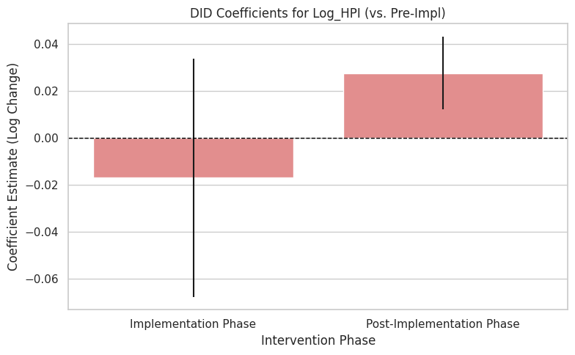
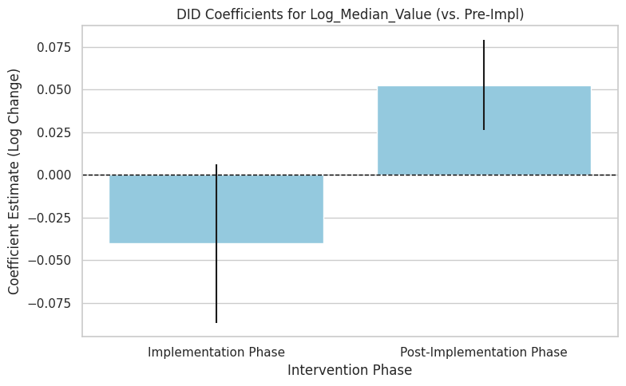H0b: The light rail implementation had no significant effect on business establishment density in treatment areas relative to control areas.
The DID regression results for log_business_density Partial evidence to reject this hypothesis.
The second hypothesis (H₀b) stated that the light rail implementation had no significant effect on business establishment density in treatment areas relative to control areas. The DID regression results for Log_Business_Density offer partial support for rejecting this hypothesis. The implementation-phase coefficient was small and not statistically significant (β = −0.014, p = .555), while the post-implementation coefficient was positive and significant (β = 0.046, p = .038). The joint test for the two phases was also significant, F(2, 117) = 6.43, p = .002, indicating that increases in business density primarily occurred after the rail line was completed. Despite these findings, the event study analysis revealed a substantial violation of the parallel trends assumption, as treatment areas experienced a relative decline in business density prior to implementation. As a result, while the evidence suggests delayed commercial growth following the light rail project, causal interpretation must be made with care, given these pre-existing differences.
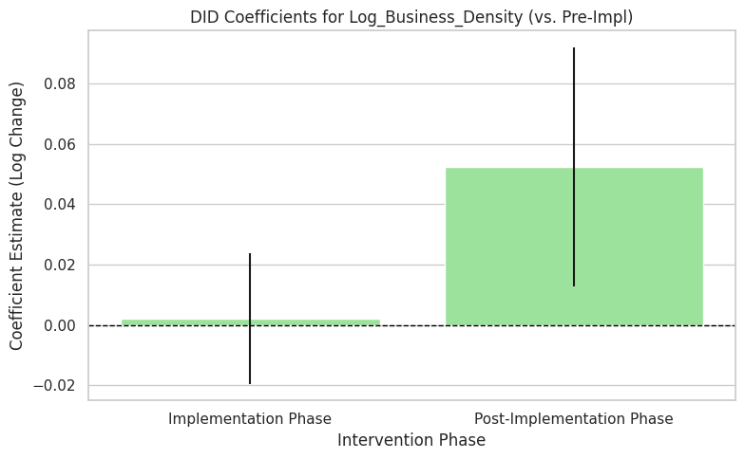
.H1d: The light rail implementation did not differentially affect retail and food service sectors compared to professional services.
The DDD regression analysis failed to reject this hypothesis.
The final hypothesis (H₁d) proposed that the light rail implementation did not differentially affect retail and food service sectors compared to professional services. The DDD regression analysis did not provide sufficient evidence to reject this hypothesis at the conventional 5% significance level. The triple-difference coefficient for the Retail and Food Service sector during the post-implementation period was β = −0.1224 with a p-value of .068. Because this value exceeds .05, the null hypothesis of no differential effect cannot be rejected. These results suggest that the light rail system did not have a strong or statistically clear differential impact on the business density of consumer-oriented industries relative to professional service industries.
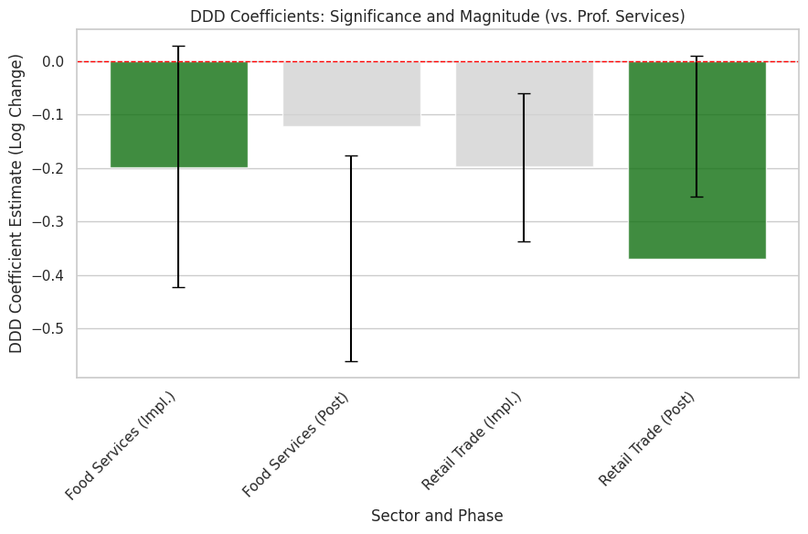
Project Overview and Key Findings
The primary objective of this project was to estimate the causal impact of a significant public transit investment in light rail on local economic conditions, specifically focusing on housing market dynamics and commercial activity. To achieve this, the project involved a comprehensive data cycle, encompassing data collection, processing, analysis, visualization, and interpretation. Data was gathered from multiple sources and needed to be processed to create a cohesive dataset. To identify causal effects, a Difference-in-Differences (DID) research design was used, comparing treatment and control ZIP codes. Additionally, a Triple-Differences (DDD) model was estimated to evaluate variations across different commercial sectors.
Key Findings: Housing and Commercial Effects
Housing Market: Strong Gains with Parallel Trend Caveats
The analysis revealed clear, statistically significant increases in housing values following completion of the light rail project. Both the Log_Median_Value and Log_HPI models showed positive, significant treatment effects, indicating that housing prices rose faster in transit-adjacent ZIP codes. However, the event study analysis for Log_Median_Value identified a statistically significant violation of the parallel trends assumption in the pre-treatment phase. While the subsequent and sustained positive post-treatment growth aligns with transit-oriented development (TOD) theory, the pre-existing divergent trends limit the strength of the purely causal inference.
Commercial Activity: Delayed Growth with Cautious Causal Interpretation
In contrast to housing outcomes, the results for business establishment density were weaker and more gradual. The Log_Business_Density model indicated a small but statistically significant increase only during the post-implementation period, suggesting delayed commercial adjustment. Critically, the event study analysis identified a notable violation of the parallel trends assumption, as business density in treatment areas declined relative to control areas prior to the light rail's opening. This pre-trend instability limits the strength of causal interpretation.
Sectoral Heterogeneity
The Triple-Differences (DDD) model found that the light rail's economic effects were not statistically significant in differentially impacting Retail Trade and Accommodation and Food Services compared to Professional Services. The DDD coefficient for the post-implementation period was marginally insignificant (P = 0.068), suggesting insufficient statistical evidence at the 5% level to conclude that consumer-facing sectors benefited more than professional services. These results suggest a more uniform, or at least statistically indistinguishable, impact across business types when controlling underlying trends.
Major Challenges Encountered and Lessons Learned
This project faced several challenges but also provided valuable lessons throughout the process. From data collection to hypothesis clarification and regression model development, each stage offered meaningful insights into the research journey.
One of the main challenges stemmed from my initial assumption that a Difference-in-Differences (DID) analysis would be comparable to a standard regression analysis. I selected my models based on commonly used approaches in the literature I reviewed, without thoroughly evaluating the process involved. This was my first major lesson: it is crucial to conduct thorough background research before committing to a methodological strategy.
Data collection also posed several difficulties that ultimately influenced the project's direction. My original goal was to conduct the analysis at the census tract level and to include additional variables such as housing affordability and income. However, The County Business Patterns dataset was only available at the ZIP code level for the relevant variables. Fortunately, I found housing data at the same geographic scale, which allowed me to proceed to compare my study to previous ones. In retrospect, this level of analysis may have been too broad to capture localized effects. Nonetheless, the data collection and preparation process became the part of the project I felt most confident in, despite recognizing some flaws as I continued to refine the analysis.
One specific issue was the Adjacency Indicator that defined the treatment and control areas. My original intent was to avoid spillover effects by creating a buffer around the light rail alignment. However, when I transitioned from a PySpark linear regression models, as well as others to the final model using the Statsmodels package, I neglected to update the control definitions. I continued to rely on the original distance measure I had created. As a result, the treatment area eventually included ZIP codes with only a small portion near a station. Refining these selections was a challenge I did not fully address. Future iterations of this project would prioritize securing census tract data to achieve greater geographic precision.
Overall, this project was a valuable learning experience in many respects. There are several components I would change in future work, but the process itself was worthwhile. Although the results did not indicate strong causal effects, the study still offers meaningful insights for both my methodological development and public policy considerations. Getting valuable experience with the data life cycle and developing and executing a project.
With that said, I do see the project as a failure on my part. I think I both under thought and over thought the project to where I cannot see an end that would be satisfactory. I do not think this capstone project fully demonstrates the skills and knowledge developed through course work. I think that is reflected in the analysis and dashboard. To that extent, Having the dataset prepared for this project I chose to do another project on the business density. I feel that project is more in line with coursework and better demonstrates the data life cycle and goals of the capstone project.

Real-World Implications Discussion
Introduction
Light rail transit systems have emerged as centerpieces of urban development strategy across the United States, promising enhanced mobility, reduced congestion, and economic revitalization. The findings from this study offer critical insights for policymakers, urban planners, and community stakeholders. However, the detected violations of the parallel trends assumption complicate the causal interpretation of these findings and underscore the need for careful, nuanced policy responses. This section explores the real-world implications of these research findings across multiple dimensions: housing affordability and displacement pressures, commercial development strategies, methodological considerations for policy evaluation, and equitable development frameworks.
Housing Market Implications
The study's most robust finding aligns with extensive research demonstrating property value premiums near transit stations. Studies across multiple cities have documented similar patterns, with research on Seattle's light rail showing increases in property values and analyses of Los Angeles transit systems revealing positive associations between proximity to light rail and residential property values (Ransom, 2018). However, this seemingly positive outcome presents profound challenges for housing affordability and social equity.
Rising property values near transit stations create what researchers term "transit-induced gentrification," a phenomenon in which enhanced accessibility is capitalized into land and housing prices, potentially displacing the very populations most likely to benefit from improved transit access (Dawkins & Moeckel, 2016). In California, analysis revealed that nearly 400 new multifamily buildings constructed within half a mile of transit stops featured average monthly rents exceeding $3,500. In contrast, median family incomes in these neighborhoods averaged less than $64,000 (NRDC, 2023).
Policy Responses to Housing Displacement
The housing implications demand proactive policy interventions before, during, and after transit construction. Research demonstrates that affordability restrictions targeted to new dwellings in transit-oriented developments (TODs) are effective tools for promoting housing affordability, improving low-income households' access to transit, and reducing transit-induced gentrification (Dawkins & Moeckel, 2016). Specifically, supply-side affordability requirements for new construction have a greater impact on sorting low-income households near transit than do demand-side housing vouchers or increases in market-rate dwelling units.
Commercial Development
The study's findings regarding commercial activity challenge common assumptions about transit's immediate economic stimulus effects. This delayed commercial response aligns with research showing that light rail transit alone cannot stimulate desired urban development without complementary policies and market forces (Topalovic et al., 2008). The finding that different business sectors showed no statistically significant differential effects further complicates simplified narratives about transit-driven commercial transformation.
Addressing Commercial Displacement and Supporting Existing Businesses
While new business formation represents one dimension of commercial activity, transit construction and subsequent development can severely impact existing small businesses through multiple mechanisms. Research on Charlotte's LYNX Blue Line found that small businesses faced significant challenges during construction, including disrupted customer access, parking limitations, and rent increases following station openings (Liu & Bardaka, 2023). These disruptions disproportionately affect small, independent businesses lacking the resources to weather extended construction periods or adapt to changing neighborhood demographics.
Progressive transit agencies have implemented business interruption funds to mitigate these impacts. LA Metro's Business Interruption Fund provides grants up to $50,000 to small businesses impacted by transit construction, having been awarded more than 840 grants totaling $20 million (LA Metro, 2022). Such programs recognize that preserving existing business ecosystems contributes to neighborhood stability and maintains the cultural character that attracted initial investment.
Methodological Implications: The Parallel Trends Challenge and Policy Evaluation
Perhaps the most consequential finding for policy evaluation concerns the detected violations of the parallel trends assumption in both housing value and business density analyses. These violations reveal that treatment and control areas were already on divergent trajectories before transit implementation, fundamentally complicating causal interpretation. For housing values, statistically significant pre-treatment differences emerged four and three periods before treatment. For business density, treatment areas exhibited a relative decline prior to the rail's opening.
Understanding Parallel Trends Violations
Parallel trends violations can arise through several mechanisms. Pre-existing neighborhood dynamics, selection into treatment areas, anticipation effects, and unobserved confounders can all generate divergent pre-treatment trends (Rambachan & Roth, 2023). These violations indicate that observed post-treatment differences may capture not only treatment effects but also the continuation of pre-existing trends.
The implications for policy evaluation are substantial. When parallel trends are violated, policymakers risk misattributing changes in outcomes to transit investments when other factors drive those changes. This can lead to inflated expectations about transit's economic impacts, potentially resulting in poor resource allocation decisions and disappointed communities (St. Louis Federal Reserve, 2004).
Equity-Centered Transit-Oriented Development: Toward Comprehensive Solutions
The study's findings, considered alongside the broader research literature, point toward the necessity of equity-centered approaches to transit-oriented development. Traditional TOD planning often prioritizes maximizing ridership and land value capture. However, increasingly, planners recognize that true success requires maintaining diverse, affordable communities that enable transit-dependent populations to remain near stations they helped justify building.
Research consistently demonstrates that TOD attracts diversity, with growth driven predominantly by non-white individuals and households led by people under 65. However, these same developments risk displacing the populations they are meant to serve (National Institute for Transportation and Communities, 2023). Equitable TOD frameworks explicitly acknowledge these tensions and proactively implement interventions across four major categories: stabilizing existing renters through rental assistance and anti-displacement policies; producing and preserving affordable housing through inclusionary zoning and land trusts; developing proactive land acquisition strategies to control real estate before speculation drives prices upward; and establishing financing mechanisms like special assessment districts or value capture to fund affordability programs.
Beyond housing, equitable TOD must address employment access, cultural preservation, and community voice. Planning processes should center community engagement from the outset, ensuring that existing residents shape development visions rather than merely reacting to predetermined plans. This includes genuine power-sharing through community advisory boards with real decision-making authority, transparent communication about potential displacement risks, and accountability mechanisms ensuring commitments are fulfilled.
Conclusion
This project examined the economic impacts of light rail transit implementation on housing markets and commercial activity using Difference-in-Differences and Triple-Differences methodologies. The analysis revealed significant increases in housing values in transit-adjacent areas, with both median home values and the Housing Price Index showing statistically significant treatment effects. However, commercial development responses were more gradual, with increases in business establishment density emerging primarily in the post-implementation period rather than during construction phases.
Critically, event study analyses detected violations of the parallel trends assumption for both housing and business density outcomes. These pre-treatment divergences indicate that treatment and control areas were already on different trajectories before transit implementation, substantially complicating causal interpretation. While the sustained positive post-treatment effects align with transit-oriented development theory, the methodological limitations necessitate caution in interpreting these findings as purely causal.
The Triple-Differences analysis found no statistically significant differential impact across business sectors, suggesting that retail and food service establishments did not benefit more than professional services from transit proximity. These finding challenges simplified narratives about transit-driven commercial transformation and suggests more uniform impacts across business types.
From a real-world policy perspective, these findings underscore both the promise and complexity of transit investments. Rising housing values, while often celebrated as development success, present profound equity challenges, including gentrification and displacement pressures that disproportionately affect vulnerable populations. The delayed commercial response suggests that transit infrastructure alone cannot guarantee immediate economic revitalization without complementary planning policies and market conditions.
Moving forward, policymakers should adopt equity-centered approaches to transit-oriented development that proactively address affordability through inclusionary zoning, community land trusts, and anti-displacement protections. Additionally, the methodological challenges revealed in this analysis highlight the need for robust evaluation frameworks that transparently acknowledge uncertainty, conduct thorough pre-trend analyses, and synthesize evidence across multiple contexts rather than relying on single studies. Ultimately, realizing transit's potential as a tool for inclusive urban development requires coordinated interventions across housing, commercial support, community engagement, and rigorous impact evaluation.

References
Al Amin, M., & Qin, Y. (n.d.). Difference-in-Differences in Stata: A Step-by-Step Guide. Princeton University, Data and Statistical Services. Retrieved October 30, 2025, from https://libguides.princeton.edu/stata-did
AZGeo ArcGIS Online. (2020, August 24). USA ZIP Codes [Data set]. https://azgeo-open-data-agic.hub.arcgis.com/datasets/azgeo::usa-zip-codes/about
Credit, K. (2018). Transit-oriented economic development: The impact of light rail on new business starts in the Phoenix, AZ Region, USA. Urban Studies, 55(13), 2838–2862.
Dawkins, C., & Moeckel, R. (2016). Transit-Induced Gentrification: Who Will Stay, and Who Will Go? Housing Policy Debate, 26(4–5), 801–818. https://doi.org/10.1080/10511482.2016.1138986
Hamidi, S., Kittrell, K., & Ewing, R. (2016). Value of transit as reflected in U.S. single-family home premiums: A meta-analysis. Transportation Research Record: Journal of the Transportation Research Board, 2543(1), 108–115. https://doi.org/10.3141/2543-12
LA Metro. (2022). Gentrification and displacement. Los Angeles County Metropolitan Transportation Authority. https://www.metro.net/about/gentrification-displacement/
Liu, C., & Bardaka, E. (2023). Transit-induced commercial gentrification: Causal inference through a difference-in-differences analysis of business microdata. Transportation Research Part A: Policy and Practice, 175, 103758. https://doi.org/10.1016/j.tra.2023.103758
National Institute for Transportation and Communities. (2023). Transit-oriented development and neighborhood change. NITC Research.
NRDC. (2018). When public transportation leads to gentrification. Natural Resources Defense Council. https://www.nrdc.org/stories/when-public-transportation-leads-gentrification
PolicyMap. (2025). Census: Decennial Census and American Community Survey (ACS) – Data Dictionary. Accessed via Mesa Community College library proxy. [https://www-policymap-com.ezp.mesacc.edu/data/dictionary#Census:%20Decennial%20Census%20and%20American%20Community%20Survey%20(ACS](https://www-policymap-com.ezp.mesacc.edu/data/dictionary#Census:%20Decennial%20Census%20and%20American%20Community%20Survey%20(ACS)
Rambachan, A., & Roth, J. (2023). A more credible approach to parallel trends. The Review of Economic Studies, 90(5), 2555–2591. https://doi.org/10.1093/restud/rdad018
Ransom, M. R. (2018). The effect of light rail transit service on nearby property values: Quasi-experimental evidence from Seattle. Journal of Transport and Land Use, 11(1). https://doi.org/10.5198/jtlu.2018.1096
St. Louis Federal Reserve. (2003). Light-rail transit: Myths and realities. https://www.stlouisfed.org/community-development/publications/bridges/lightrail-transit-myths-and-realities
Topalovic, P., et al. (2008). Community impact & economic analysis of light rail transit. ResearchGate. https://www.researchgate.net/publication/242597308_Community_Impact_Economic_Analysis_of_Light_Rail_Transit
U.S. Census Bureau. (2025). County Business Patterns (CBP). U.S. Department of Commerce. https://www.census.gov/programs-surveys/cbp.html
Valley Metro. (2025). Developers resources. Valley Metro Regional Public Transportation Authority. https://www.valleymetro.org/contact/developers-resources
Zillow Group. (2024). Housing data. Zillow. https://www.zillow.com/research/data/

